Document Number | QRP3
Document Title | Quality Auditing Process
Department Ownership | Quality & Risk Department
Document Type | Procedure
Department Owner | Derrick Chan
Document Author | Derrick Chan
Last Edited By | Nick Filevski | Lasted Edited On | 02/12/2014

Purpose

Internal audits are conducted at planned intervals to determine whether the Quality Management System conforms to the planned arrangements to the requirements of ISO 9001:2008 and to ensure that non-conformances, corrective and preventive actions are effectively controlled and maintained through the Process Improvement Requests (PIR/ BIR and SIR)

Scope

The scope of this procedure shall apply to the scheduling, planning, control of non-conformances, and corrective and preventive actions at the recording of all internal audits.

Reference Documents

QMS Database User Manual (refer to procedure)
Australian/New Zealand Standard ISO 9001:2008
QMS Training Manual (refer to procedure)

Definitions

Objective Evidence – Is based on observations, measurements or tests which can be verified. Qualitative or Quantitative information, records or statements of fact pertaining to the quality of an item or service or for the existence and implementation of quality system elements.

Auditors – Personal who assist with the internal audits and have been trained as internal quality auditors.

PIR – Process Improvement Request
OR – Observation Request
BIR – Business Improvement Request
SIR – Safety Improvement Request

Flowcharts (Other Images)

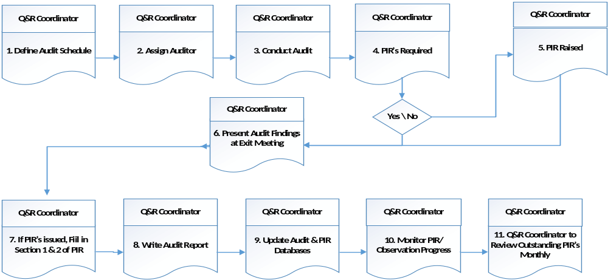

Procedure

General

Quality and Risk Department are also responsible for arranging the scheduling, planning, preparation, execution and recording of all regular internal quality audits on work procedures, policies, user manuals and templates within the certified departments.

Information for Managers and Supervisors

General

- Audits are carried out to ensure staff are following a documented process that reflects best practice.
- Audits generally should take about 3 hours from preparation to completion. This varies and is not a rule.
- Quality & Risk Representatives of each certified department are responsible to take timely action to eliminate any causes of nonconformities that may be raised at an internal audit.
- The Quality and Risk Coordinator is responsible to conduct follow up activities that include verification of the corrective action and the reporting of those results.
- Any enquires could be referred to the Quality & Rick Coordinator and the Quality & Risk Manager

Your section is being audited

- The auditor will contact you to arrange an audit. You need to select someone from your team to be audited and notify the auditor. Generally, you pick the person most familiar with the process if you want to test the documentation, or you can select a person who you believe needs to be checked as to whether they fully understand the process. Either way, an audit is meant to be a positive business improvement process and should not be seen as threatening in any way.

- Ensure that the auditee you nominate checks that the work procedure to be audited is still current and valid. If a process has not been used since it was lasted audited then there is no reason to audit it again. Notify your auditor of this.

- Use the time available within the month to negotiate the best time for the audit which will reduce the impact on your operation.

- Define Audit Schedule

Work procedures operating within the certified departments shall be audited at regular intervals as determined by the Quality & Risk Department.

Audits should be scheduled frequently if the process or activity is of a critical nature

The Quality & Risk Coordinator shall arrange for the preparation of the internal quality audit schedule annually

The schedule shall also consider the following decision factors:-

- If the process is a critical activity then it is a priority for auditing;

- If the process is newly created or revised then it is a priority for auditing;

- If the process has received previous PIR’s then it is a priority for auditing;

- If the process is currently under review or subject to action requests then an audit may not be appropriate;

- If the process is an occasional one, it is only to be scheduled for audit if the process has been done since it was last audit;

- Unless the above factors intervene then the processes that have not been audited for the longest time set the priority;

- The above factors are used to determine the most important processes for auditing. In addition, the following management factors must be taken into consideration;

- In each month there should be a reasonable spread of audits across the certified departments;

- There is not more than one audit scheduled at the same time in a department unless the circumstances are exceptional;

- A section is not over-committed with providing auditors as well as being audited in the same monthly schedule;

- Some consideration is made to the fluctuating operational commitments and human resources (I.e. staff on leave) of a particular time.

Reason: To define processes that requires auditing
Output: Audit schedule is QMS database

- Conduct Audit

Entry Meeting
The audit commences with the entry meeting between the auditor and auditee. The meeting has the following objectives

- To introduce the auditors to the auditee;

- To confirm the audit scope and purpose

- To provide an overview of the methods and procedures to be used to conduct the audit;

- To confirm the exit meeting time, date and venue;

- To clarify any uncertainties that the auditee may have of the audit process;

The Audit

The auditor prepares a Quality Auditing Checklist prior to the audit and uses it as an aid when conducting the audit. The checklist is comprised of questions that are based on the key outputs from the work procedure. The question are used to seek evidence that these outputs have been completed as required.

The auditors commence the audit by collecting evidence though interviews, examinations of documents, observation of activities and conditions in the audit area.

The auditor and audit team members, where applicable, shall:

- Review & determine any causes for non –conformance;

- Record any non-conformities on a PIR and state planned completion date;

- Evaluate the need for action to prevent non-conformities form reoccurrence;

- The following terminology shall be used on the checklist by the audit team to denote the compliance status:

- Acceptable;

- Not Acceptable;

- Not Applicable (N/A);

- See Comments.

The auditor shall make the decision to abort the audit if it appears that the audit objective becomes unattainable E.g. the process is redundant or has been implemented in this section, and then a PIR should be raised.

Reason: To introduce auditors to auditees, ascertain purpose, provide methods to conduct audit and to explain any doubts the auditees may have of the audit processes.
Output: Completed audit report summarizing the audit, any PIR’s raised and any relevant attachments.
Retention: The Quality Audit Entry Meeting Checklist & the Quality Audit Checklist are attached to the audit report and retained in the file within the section for 2 years. The reports are then attached to a correspondence file for the records retention.

- PIR’s required?

Prior to the exit meeting the auditor shall evaluate apparent PIR findings or adverse observations to ensure that they are valid audit findings. Where applicable, the evaluation process should include a meeting to discuss the apparent PIR finding by the audit team. PIR’s may be raised where an issue has been identified that relates to process improvement or of non-conformance against a work procedure. If a work procedure or user manual becomes redundant and a decision is made between the auditor and auditee to re-write the process a PIR must be raised and a timeframe for completion is to be stipulated.

Reason: To clarify validity of PIR’s
Person Responsible: Auditor

- PIR Raised

Where there is objective evidence of an issue that relates to process improvement or of non-conformance against a work procedure or user manual, then a Process Improvement Request (PIR) form shall be completed.

Reason: To ensure PIR findings are recorded for future auditors
Output: PIR form and on the PIR Register
Retention: 2 Years

- Present Audit Findings at Exit Meeting

The audit concludes with an exit meeting with the auditee. The object of the meeting is to present the audit findings to the auditee in a manner which ensures they understand the results of the audit.

At the exit meeting, which the manager of the area being audited may be invited to attend, the auditor shall complete the Audit Exit Meeting Checklist (see Appendices) which includes the following tasks:

- Record of attendance;
- Present audit findings and Process Improvement Request (PIR);
- Obtain the auditees signature on PIR to acknowledge that the findings is understood (this does not indicate agreement). If the auditee refuses to sign any PIR’s the auditor shall record the reasons;
- Take photocopies of all PIR’s (with signatures) and leave originals with the auditor and copies provided to the auditee; the auditor to return originals to the QA coordinator;
- Advise the auditee that the formal audit report shall be issued within ten (10) working days of the exit meetings;
- Advise the auditee that PIR’s included within the report must be responded to within ten (10) working days of issue. The auditor shall place a notice to that effect on the audit report file.

Note: Step 5 can be completed prior to the exit meeting or the PIR’s can be mentioned at the exit meeting with the PIR form to follow. Each PIR must describe:

- What is the issue and the effect it has
- What will be done to address the issue and prevent reoccurrence of it (this section is to be completed by the auditee and a planned completion date entered); and
- State if any PIR’s were closed out during the meeting.

Reason: To confirm the result of the audit

- If PIR’s issued fill in section 1 &2 of PIR

Note: Step 6 can be completed prior to the exit meeting (Step 6) or the PIR’s can be mentioned at the exit meeting with the PIR form to follow.

If PIR’s were issued they require:

Section 1: “What is the issue and what effect do you believe it has?” And section 2 “What will be done to address the issue and prevent re-occurrence” to be filled in.

For section 2:
If the PIR was raised because of non-compliance with an accurate process then the auditee shall fill in the PIR including the planned completion date.

If the PIR was raised because the process requires updating/amending or improving then then process owner or the auditee shall fill in the PIR including the planned completion date.

Reason: To identify corrective and preventive action

- Write Audit Report

The Audit Report

The auditor is responsible for preparing and issuing an audit report within ten (10) working days of the exit meeting. The auditor is responsible for the reports accuracy and completeness.
The audit report shall be prepared using the following five (5) part standard format:

The quality Audit Report Sheet shall be completed in full and signed by the auditor. A summary of the audit, which refers to any PIR issued, should provide sufficient information as to the findings of the audit;

- The Entry/Exit Meeting Checklist

- Quality Audit Report

- A copy of each PIR, SIR and BIR

Distribution of the Report

- The auditor shall pass the original report with the entry/exit meeting checklist, quality audit checklist and any PIR’s raised to the QA coordinator to be filed.

- One copy of the entire set shall be given to the auditee and if an exit meeting was held then a copy of the report shall be given to the auditee’s manager.

Reason: To provide audit information
Output: Audit Report
Retention: 2 years, filed and referenced by audit number in the Quality and Risk Area document schedule template for the appropriate month. If no follow-up is required, then state why e.g. minor document change only; to be checked at next scheduled audit etc.

- Update Audit & PIR, SIR and BIR Databases

The databases are updated to show the audit has been completed and to record any PIR’s and observations raised. If a follow-up is required through audit then complete the follow-up field in the PIR database and record on the PIR form. Schedule the follow-up audit on the word.

Reason: To track PIR’s
Output: Added to QMS database
Retention: 2 years

- Monitor PIR/Observation progress

The Quality & Risk coordinator will review the outstanding PIR’s and Observations monthly and follow-up relevant personnel for actions.

Reason: Ensure PIR’s /Observations are closed out by agreed times
Output: Update the PIR and Audit Report databases
Retention: 2 years in office, then placed on correspondence file for permanent storage. Permanent on Electronic databases

- Quality & Risk coordinator to review outstanding PIR’s monthly

At the end of each month, the audit report and PIR databases are checked and updated. The reports and PIR’s are reviewed.

Reason: To monitor effectiveness of systems

Appendices

